Exercise on data frame

- Create a data frame from the data given below
Name | Age | Gender | Salary
John | 28 | Male | 50000
Alice | 34 | Female | 62000
Bob | 45 | Male | 48000
Emma | 22 | Female | 55000
Mike | 40 | Male | 70000
Sophia | 29 | Female | 45000
David | 50 | Male | 80000
Lily | 27 | Female | 51000
James | 36 | Male | 73000
Olivia | 20 | Female | 61000

- Print the data frame
- Perform data inspection
1. Inspecting the Data
You should always start by understanding the structure of your dataset.
a. Basic Inspection
- View the first few rows of the dataset:
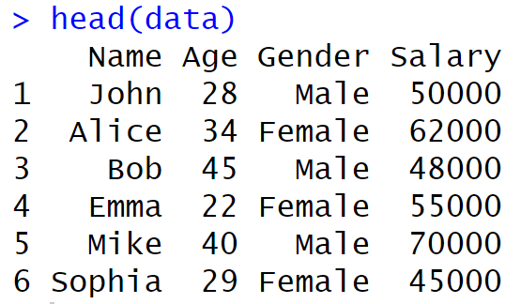

Structure of the dataset: Shows the data types and provides an overview of the variables.
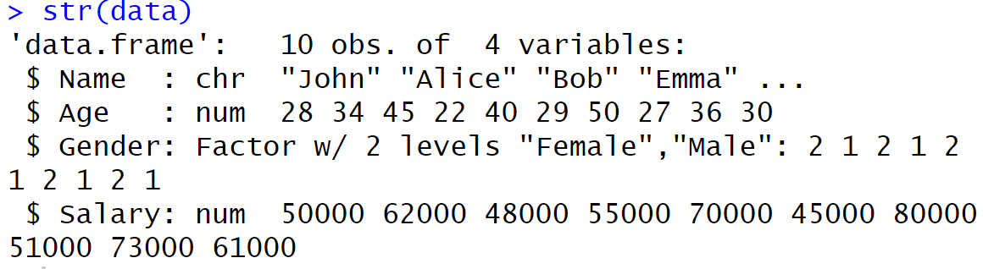

Generate summary statistics for each column:
This will give you basic statistics for numeric variables (e.g., Age and Salary) and frequency counts for categorical variables (e.g., Gender).
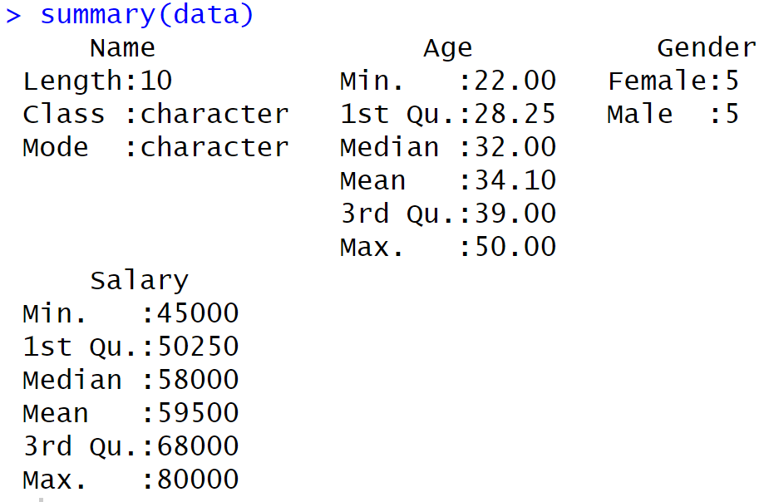

- Exploring distributions and relationships.

a. Summary Statistics for Numeric Columns
Let’s get specific summary statistics for numeric columns like Age and Salary:
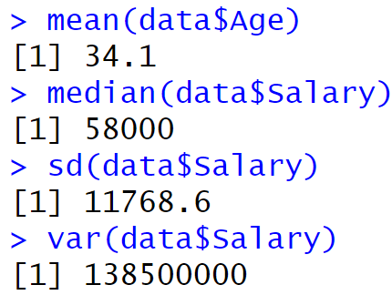

b. Exploring Categorical Variables
- Frequency counts for Gender:
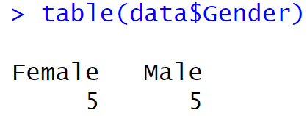

4. Visualizing the Data
Visualizations help you understand relationships and patterns in your data.
a. Histogram for Numeric Variables
A histogram can show the distribution of variables like Age and Salary:

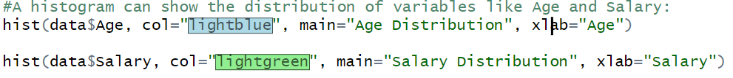

Bar Plot for Categorical Variables
- Gender distribution using a bar plot:

Boxplot for Salary by Gender
Boxplots are useful for comparing distributions across groups (e.g., comparing salaries between males and females).
What can be inferred from the above box plot?
The box plot you've shared shows the distribution of salaries by gender (Male and Female). Here are a few key observations and inferences based on the box plot:
- Median Salary:
  - The thick horizontal line in each box represents the median (middle value) of the salary distribution.
  - The median salary for females is lower than that for males, as the black line for females is below that of males.
- Interquartile Range (IQR):
  - The box represents the interquartile range (IQR), which is the range between the 1st quartile (25th percentile) and the 3rd quartile (75th percentile).
  - The IQR for females is smaller, suggesting that the salary distribution is more concentrated within a narrower range compared to males, whose IQR is larger.
- Range and Whiskers:
  - The whiskers extend from the box to the minimum and maximum values that are not considered outliers.
  - Males have a wider range of salaries compared to females, as indicated by the longer whiskers.

- Potential Outliers:
  - There do not appear to be outliers for either gender, as no individual points are plotted outside the whiskers. Outliers would be displayed as individual dots.
- Overall Salary Spread:
  - The overall spread (range) of salaries for males is larger than for females, indicating greater variability in male salaries.
  - Female salaries appear to be more tightly clustered around the median.
Conclusion:
The box plot suggests that there is a noticeable gender gap in salary, with males having both a higher median salary and a wider distribution of salaries compared to females. This could be indicative of gender-based salary differences, but further statistical analysis would be needed to confirm any significant differences.

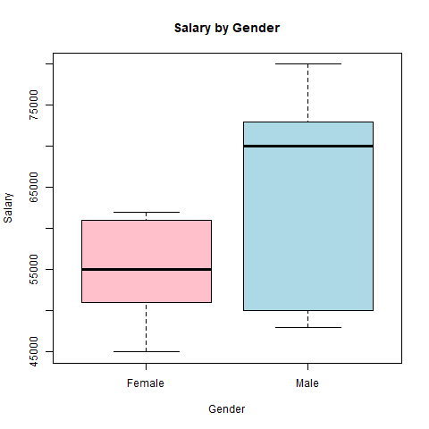
This boxplot compares the salary distribution by gender. Here are some valuable insights:
- Salary Range: Males have a wider range in salaries compared to females, suggesting more variability in their salaries.
- Median Salary: The median salary for males is higher than that for females, indicating a potential gender disparity in median pay.
- Interquartile Range (IQR): The IQR (distance between the first and third quartiles) for males is larger than that for females, showing greater salary dispersion among males.
- Outliers: The plot shows possible outliers for both genders, suggesting that some individuals earn significantly higher or lower salaries than the typical range for their gender.
- Overall Salary Comparison: In general, males have a higher salary distribution than females, as evidenced by the position of their boxplot above that of females.

Scatter Plot for Numeric Variables
If you want to examine the relationship between two numeric variables like Age and Salary, a scatter plot is a great tool:

Correlation Analysis
If you have multiple numeric variables, you can check for correlations between them. In this case, let's check the correlation between Age and Salary:
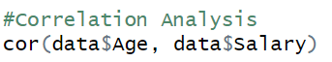

A correlation coefficient of 0.5711525 indicates a moderate positive linear relationship between two variables. Here’s what this number tells us:
- Direction:
  - Since the value is positive, it means that as one variable increases, the other variable tends to increase as well. In other words, there is a direct relationship between the two variables.
- Strength:
  - A correlation of 0.571 falls in the range of 0.5 to 0.7, which is typically interpreted as a moderate correlation. While there is a positive relationship, it is not very strong, but it’s not weak either.
- Interpretation:
  - The closer the value is to 1, the stronger the positive linear relationship. A value of 0.571 suggests that while there is a positive trend, other factors might also be influencing the relationship, and the variables are not perfectly correlated.
In practical terms, this means that knowing the value of one variable gives some useful information about the other, but it does not allow for precise predictions.

